# Chapter 2

## 2.1 Overview of NFC

Near Field Communication (NFC) is a communication protocol based on radio frequency identification (RFID) for exchanging data between two connected devices within close range (< 10 cm). NFC communication compromises of three types of data exchange process: read/write mode that involves an interrogator that reads information from NFC tag, card emulation mode that allows an NFC-enabled mobile phone to act as contactless smart card, and per-to-peer mode where two NFC devices exchange information with each other. (Sutjiredjeki et al., 2020)

Near Field Communication is a set of short-ranged wireless technologies, typically requiring a distance of 4cm or less to initiate connection. NFC lets you share small payloads of data between an NFC card and a mobile device or between two mobile devices (Android Developers, 2023).

NFC is a higher version of the already existing proximity card standard that combines the interface of a smartcard and a reader into a single device. It allows users to seamlessly share content between digital devices, pay bills wirelessly, travelling ticket on existing contactless infrastructure used in public transportation (GSMArena, 2024).

A remarkable advantage of NFC over Bluetooth is the shorter set-up time. Instead of the manual configurations to identify Bluetooth devices, the connection between devices are established at once (under a 1/10 second) (GSMArena, 2024).

Due the short range, NFC provides a higher degree of security than Bluetooth and makes NFC suitable for crowed area when it involves sending signals with its transmitting physical devices.

NFC can also work when one of the devices is not powered by battery (example on a phone that may be turned off, a contactless smart credit card e.t.c.) (GSMArena, 2024)

NFC comprises of a group communication protocols that make it possible for two compatible devices, often no more than four centimeters to share data with just a single tap but in order for the technology to function, both devices needs to be compatible with it - i.e., both a target device and an initiator device.

Nokia, Sony and Philips who formed the NFC Forum in 2004, are also responsible for setting NFC standards and certifying devices that were NFC compliant.

The already existing radio frequency identification (RFID) standards such as ISO/IEC 14443 and FeliCa served as the foundation for the development of the NFC standards. These standard been maintained, ensures that the NFC-compatible devices from different manufacturers can communicates with each other. Due the lack of encryption in NFC ensures that it is compatible with RFID technologies.  
  
NFC-enabled devices needs a application software in order for such devices to function as their manufacturers intended them to be. Without the application software, compatible devices cannot make payments or read smart NFC poster.  
  
The NFC technology is used to facilitate contactless payments in Apple Pay and Samsung Pay for smartphone users, to wirelessly charge wearable fitness devices, and to provide key card access to offices and schools.( Spiceworks. (2023). *What is near-field communication (NFC)?*

)

Communication in NFC devices can occur either if they both devices are active or one is active and the other is passive. Active communication mode means both the target and initiator devices have a power source, and they can alternately generate a field through which they can communicate and the deactivates its radio frequency (RF) field while waiting to receive data.

Passive communication mode means that The initiator device supplies a carrier field while the target device is responsible for modulating the field that is already present in this mode. The passive device lacks power and has to draw its power from the electromagnetic field of the initiator device.

Near Field Communication (NFC) is a contactless communication technology operating over a radio using a base frequency of 13.56 MHz with a typical range of up to 2cm and data rate from 46kbit/s up to 1.7 Mbp/s. NFC is unique in that one side can also transmit power over the connection allowing for battery-less operating models. NFC enables connections foe a variety of products including mobiles, tablets, wearables, automobiles, door locks, along with battery-less use case like tags in apparel, packaging and other consumer products.

The user experience for NFC is centered on a tap which has different operating modes like card emulation mode, Reader/Writer mode, Wireless Charging mode, Host card emulation, Peer-to-peer mode and secure element based card emulation.

The NFC tags are contactless memory cards hosting a specially formatted data payload specified as an NDEFF record (NFC Data Exchange Format). Tags types differs by the underlying communication protocol and data structure to store NDEFF messages but the resulting overall behavior of NFC Tags is identical. (NFC Forum. (2023). *Learn about NFC technology*

)

NFC stands for a Near Field Communication, a miniaturized communication technology that allows two devices to communicate with each other by touching them together or bringing them in close proximity.

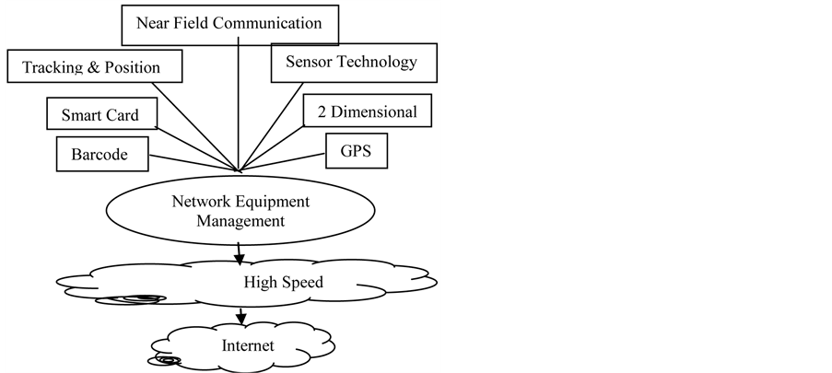

## 2.2 Application of NFC

The potential applications of NFC tags are vast and constantly evolving in areas like payment system, marketing promotion, transportation system, smart homes application and healthcare application, logistics and shipping, Manufacturing.(RF Wireless World, 2022)

## 2.2.1 Contactless Payments

NFC has been applied in mobile payment system, by storing payment credentials within digital wallet on your phone, you can tap your device at the compatible are to make your purchase fast and seamless. (Tappr, 2022)

## 2.2.2 Marketing Promotions

Marketing campaigns has been enhance by embracing NFC by embedding tags within posters

Or flyers. Tapping these tags with your phone can instantly redirect you to a website, display a product video or provide additional product information. (Tappr, 2022)

## 2.2.3 Public Transportation

Many Transportation companies have embraced NFC technology for their public transit. Passengers can tap their travel cards embedded with NFC chips at designated readers to seamlessly pay fares. (Tappr, 2022)

## 2.2.4 Smart Homes

By using NFC and RFID technology, you can control our household equipment, app lauching, access/lock doors, set alarm functions. (RF Wireless World, 2022)

## 2.2.5 Logistics And Shipping

By incorporating NFC to logistics and shipping, you can easily track and scanning of goods using smart tags make the system smart, errorless and efficient. (RF Wireless World, 2022)

## 2.2.6 Manufacturing

Most modern manufacturing industries using NFC smart tags to identify each product from its different process stages within the company, packaging, transportation and tracking of products during shipment giving a unique identification number allow manufacturers to efficiently mange products in case of return during the warranty period for replacement, service and maintenance.

(RF Wireless World, 2022)

# 2.2 Overview of Healthcare system

The Nigeria health system is weak and has been evolving over the years with misplaced priorities and the focus on health inputs rather than outputs. From 1960 till date, the design and adoption of several policies have contributed little to strengthening the health system towards improvement in health outcomes. Aregbeshola (2021). Nigeria has seen major attempts to strengthen primary healthcare through the Saving One Million Lives (SOML) initiative, and move to towards universal health care, through the National Health Act. Though both initiatives were successfully adopted, but faced political and institutional challenges in implementation and sustainability (Kevin Croke and Osondu Ogbuoji 2023).

The SOML began in 2012 and was expanded in 2015. However, the programme’s head left government in 2013, a key funding source was eliminated in 2015, and the programme did not continue after external funding elapsed in 2021.

Primary healthcare in Nigeria, particularly in rural areas, has come a long way, but more work is undoubtedly still needed to realize the objective of universal health now and in the future. Priority should be given to improving people's living conditions beyond the current poverty level in order to promote healthier living. Dada, Sholadoye. (2023).

# 2.3 Overview of NFC in Healthcare system

Healthcare is growing rapidly among numerous business utilizing Near Field Communication (NFC) to enhance comfort, boost productivity, and streamline procedures. NFC provides simplicity, privacy and predictability that favors the healthcare system.

The Near Field Communication technology has the potential to transform hospital because of its ability to facilitate seamless data transfer and interactions between devices.

The NFC technology can be used in patient identification and tracking, medication management, Electronic Health Records (EHRs), Medical Device Connectivity, Vital Signs Monitoring, Infection Control, Nurse Call Systems, Assert Tracking, Patient Discharge and follow-up.

The NFC-card are equipped with internal memory, patients can have critical information stored on their NFC card for fast access in critical situations. This information can vary and can be configurable, the information such as name, blood type, allergies can be stored as a critical fast access data.

## 2.4 Overview of IoT relating to NFC

NFC when integrated with IoT has a significant way to enhance the way connected devices interact and automate various tasks. NFC been a wireless communication technology that enables data exchange between devices over short range, can be used to connect IoT devices to websites, mobile applications which provide a seamless user experience. When NFC is enabled in IoT, users can easily interact with all connected devices and can access information and services through websites and mobile applications. (Sutjiredjeki et al., 2020)

NFC based IoT has the potential to revolutionize a wide range of industries and applications, so when combined, can enable a new level of interactions and automation. Example NFC-based IoT devices can be controlled and monitored remotely and can also communicate with each other devices and systems. NFC can be used to securely authenticate and authorize IoT devices so as to protect against unauthorized access and tempering. There are also some challenges with with NFC-based IoT devices while integrating, we face challenges like security, data privacy and interoperability.(Gawande et al., 2023)

## 2.5 Using IoT approach for Healthcare

IoT technologies in the healthcare industry represents a transformative shift with tangible benefits. IoT devices can be used to monitor patients, manage medical equipment and track inventory. It can also be used to manage environmental factors such as temperature, humidity and air quality which can also help to prevent the spread of infections. It also helps in tracking location of patients and staffs through utilizing wearable devices, RFID tags or smartphone-based solutions. It can also help in remote patient monitoring which can help improve patient outcomes by detecting changes in health status early and enabling healthcare providers to intervene quickly such devices like wearable devices, sensors and telecommunication tools to remotely monitor patients’ health status, collect relevant health data and facilitate virtual consultations between patients and healthcare providers.

## 2.6 The growing importance of NFC in Healthcare system

## 2.7 Existing Healthcare registry system

## 2.8 Application of NFC in Healthcare system

## 2.9 Conclusion

1. Reference:  
   Android Developers. (2022, June). *NFC overview*. Retrieved December 13, 2024, from <https://developer.android.com/develop/connectivity/nfc>
2. GSMArena. (2024, August). NFC. Retrieved December 13, 2024, from <https://www.gsmarena.com/glossary.php3?term=nfc>
3. RF Wireless World. (2022, March 15). *Applications of near field communication and its future*. RF Page. <https://www.rfpage.com/applications-near-field-communication-future/>
4. Aregbeshola, Bolaji Samson, Towards Health System Strengthening: A Review of the Nigerian Health System From 1960 to 2019 (January 14, 2021). Available at SSRN: <https://ssrn.com/abstract=3766017> or [http://dx.doi.org/10.2139/ssrn.3766017](https://dx.doi.org/10.2139/ssrn.3766017)
5. Daada (November 2023). An overview of the primary healthcare system in Nigeria. ResearchGate. <https://www.researchgate.net/publication/376698801_AN_OVERVIEW_OF_THE_PRIMARY_HEALTHCARE_SYSTEM_IN_NIGERIA>